Update of “Trento-Bologna on foot”
July 2022
- P.14 In the paragraph (just below the middle) beginning with “The grass and gravelpaths” it is mentioned that the dykes are sometimes completely overgrown.
  - I have not found any reliable information that indicates when the dikes are mowed.
  - But based on some observations, I have the impression that in May/June you have to take into account that the dykes might be difficult to access.
- P.17 addition after the last sentence ending with: “the pleasure that you have in the ascent”
  - At the 10th final meeting between footpath and tarmac You will come across a sign indicating that there is no access because of road works ahead. It seems wisest to follow the tarmac from there. On map 8 you can see that the tarmac road is not much longer than the footpath.
    - Where the sign is placed you cannot yet see the actual roadworks. Further on, the blocking of the foothpath is clearly marked with red-white ribbons.
- P.19: change of the suggested accommodation for day 9 (because Lodging House Santa Chiara is permanently closed in the meantime)
- P.23 comment to the last sentence just above the part in italics, ending with “up to Bologna”
  - When you choose a lower route (on an unpaved path with more shade) it happens that this lower route stops and you have to climb up or walk back a bit.
- P.23 change to the last sentence ending with “direction 16 (map 3).”
  - You will only encounter benches again in the second part of the route between directions 15 and 16.
- P.25 comment to “Alternative Calliano”
  - Even if you do not spend the night in Calliano, I think the alternative route is preferable (more beautiful, unpaved and, above all, much quieter).
- P.29 comment on the 3rd paragraph in italics beginning with “In April 2018…”
  - This diversion was still there at the end of June 2022.
- P.33 change 1st italic text paragraph: B&B da Mariangela is permanently closed.

- P.33 addition of an alternative route at direction 44 (borghetto-peri via belluno veronese.gpx)
  - If you have an overnight stay in Belluno Veronese (3.8 km from there), turn right at direction 44 and follow the cycle path to Verona. Also the next day, when you leave Belluno Veronese, follow the cycle path to Verona if you want to go to Rivalta and Peri. If you cross the bridge to Peri at Rivalta and later follow the bend to the right and then pass under the railway bridge, you are back on the main route (via Borghetto), where you continue reading at direction 50.
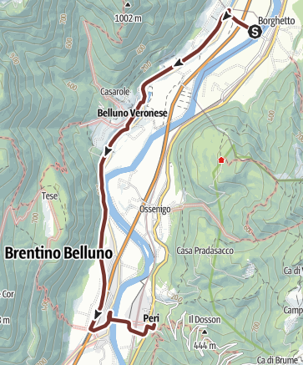

- P.37 at direction 59 a fruit and vegetable shop is mentioned. In the meantime this is now a small supermarket.
- P.37 at direction 60 Schioppo a cafe, restaurant, shop is mentioned.
  - In 2022, the café and restaurant turned out to be closed. There is only a butcher's shop, but no coffee is served there.
- P.37 change of the last three sentences above the image:
  - You do not turn sharply left, but you continue your way and keep following the E5. Several bends follow and in between you walk on tarmac.
- P.39 comment on the mentioned overnight stay at the bottom of p.39
  - B&B Montecchio is permanently closed from July 2022
- P.69 delete 2nd paragraph in italics
  - The text describes the route to an accommodation (Lodging House Santa Chiara) that has now been permanently closed.

- P. 73 replacement direction 184
  - New text direction 184: After the first roundabout you can walk on a bike path (which mostly runs along Via Corticella) until you reach Primo Maggio. There you turn right, cross carefully and turn left (there is a pavement on the left). You then go under the railway track. See further direction 187. (trebbo-di-reno-corticella.gpx). The route in the gpx file and on the map below starts from the accommodation Case Osti (see map 27 and map 28, accommodation number 27B)

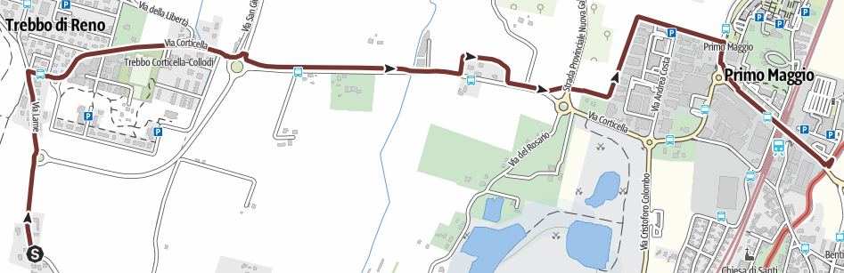

- P.75 addition of text at the end of the 1st paragraph.
  - In the park, keep to the right. You will reach a bridge that you will cross (see the barrier in the middle on the left side of the map). Immediately after the bridge, turn left and at the end, turn left. (Then continue reading at the beginning of the 2nd paragraph.)

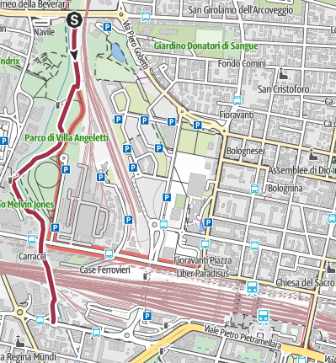

The dark red line (via yuri gagarin-via.gpx) on the left indicates the main route from Via Yuri Gagarin (see indication 189), until you have passed under the railway track, until you turn left towards the railway station Bologna Centrale (=direction 190).

The light red line (on the map above runs to the right of the dark red line) indicates the CSA route. That CSA route brings you to the rear of the station.

